Lorenzo Bonnick Vilela

### CAPTURAS Y ENLACES REPOS.Unidad didáctica 2

### Ejercicio 01.1: Android Studio and Hello World:

### Captura MainActivity:

### 

### Captura Emulador:

### 

### Link Github: <https://github.com/lorenzobv/Ej.1.1_HelloWorld>

### Ejercicio 1.2 Part A: Your first interactive UI

### Captura MainActivity:

### 

### Captura Emulador:

### 

### Link Github: <https://github.com/lorenzobv/E.j.1.2_Your-first-interactive-UI>

### Ejercicio 1.2 Part B: [The layout editor](https://codelabs.developers.google.com/codelabs/android-training-layout-editor-part-b/index.html?index=..%2F..%2Fandroid-training#0)

### Captura MainActivity:

### 

### Captura Emulador:

### 

### Link Github: <https://github.com/lorenzobv/E.j.1.2_Your-first-interactive-UI/tree/master/app/src/main/res>

### Ejercicio [1.3: Text and scrolling views](https://codelabs.developers.google.com/codelabs/android-training-text-and-scrolling-views/index.html?index=..%2F..%2Fandroid-training#0)

### Captura MainActivity:

### 

### Captura Emulador:

### 

### Link Github: <https://github.com/lorenzobv/Ej.1.3-Text-and-scrolling-views>

### Ejercicio [1.4: Learn to help yourself](https://codelabs.developers.google.com/codelabs/android-training-available-resources/index.html?index=..%2F..%2Fandroid-training#0)

### Captura MainActivity:

### 

### Captura Emulador:

### 

### Link Github: <https://github.com/lorenzobv/Ej.1.4-Learn-to-help-yourself>

### Ejercicio [2.1: [Activities and intents](https://codelabs.developers.google.com/codelabs/android-training-create-an-activity/index.html?index=..%2F..%2Fandroid-training#0)](https://codelabs.developers.google.com/codelabs/android-training-available-resources/index.html?index=..%2F..%2Fandroid-training#0)

### Captura MainActivity:

### 

### Captura Emulador:

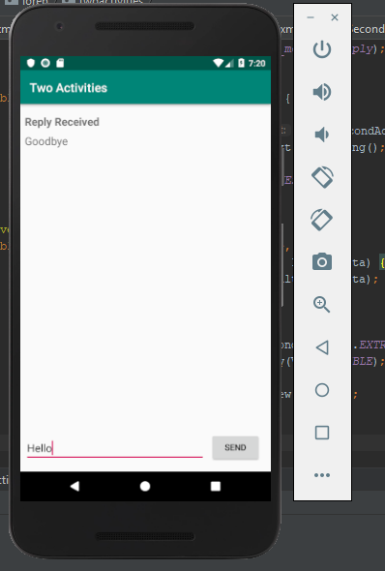

### Link Github: <https://github.com/lorenzobv/Ej.2.1_Activities-and-intents_2.2-Activity-lifecycle-and-state>

### Ejercicio [2.2: [Activity lifecycle and state](https://codelabs.developers.google.com/codelabs/android-training-activity-lifecycle-and-state/index.html?index=..%2F..%2Fandroid-training#0)](https://codelabs.developers.google.com/codelabs/android-training-available-resources/index.html?index=..%2F..%2Fandroid-training#0)

### Captura MainActivity:

### 

### Captura Emulador:



### Link Github: <https://github.com/lorenzobv/Ej.2.1_Activities-and-intents_2.2-Activity-lifecycle-and-state>

### Ejercicio [2.3: [Implicit intents](https://codelabs.developers.google.com/codelabs/android-training-activity-with-implicit-intent/index.html?index=..%2F..%2Fandroid-training#0)](https://codelabs.developers.google.com/codelabs/android-training-available-resources/index.html?index=..%2F..%2Fandroid-training#0)

### Captura MainActivity:

### 

### Captura Emulador:

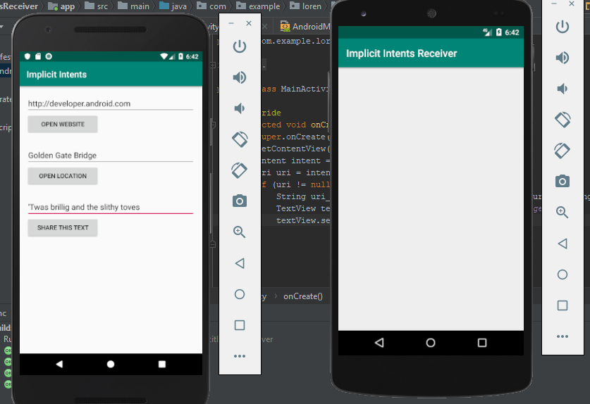

### Link Github: <https://github.com/lorenzobv/Ej.2.3_Implicit-intents>

### <https://github.com/lorenzobv/Ej.2.3_Implicit-intents_task_5>

### Ejercicio [3.1: [The debugger](https://codelabs.developers.google.com/codelabs/android-training-using-debugger/index.html?index=..%2F..%2Fandroid-training#0)](https://codelabs.developers.google.com/codelabs/android-training-available-resources/index.html?index=..%2F..%2Fandroid-training#0)

### Captura MainActivity:

### 

### Captura Emulador:

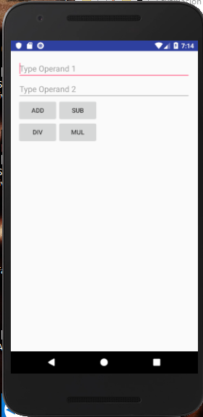

### Link Github: <https://github.com/lorenzobv/Ej.3_Completo>

### Ejercicio [3.2: [Unit tests](https://codelabs.developers.google.com/codelabs/android-training-unit-tests/index.html?index=..%2F..%2Fandroid-training#0)](https://codelabs.developers.google.com/codelabs/android-training-available-resources/index.html?index=..%2F..%2Fandroid-training#0)

### Captura MainActivity (Calculator test):

### 

### Captura Emulador:

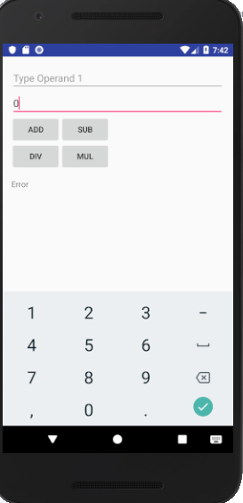

### Link Github: <https://github.com/lorenzobv/Ej.3_Completo>

### Ejercicio [3.3: [Support libraries](https://codelabs.developers.google.com/codelabs/android-training-support-libraries/index.html?index=..%2F..%2Fandroid-training#0)](https://codelabs.developers.google.com/codelabs/android-training-available-resources/index.html?index=..%2F..%2Fandroid-training#0)

### Captura MainActivity:

### 

### Captura Emulador:

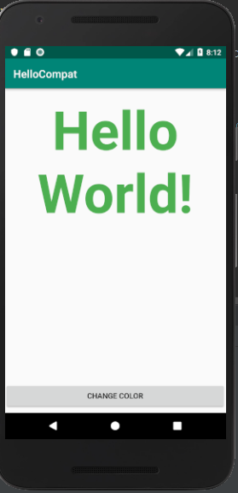

### Link Github: <https://github.com/lorenzobv/Ej.3.3_HelloCompat>